1. UML Diagram

|  |
| --- |
| Player |
| - imgPlayerEast, imgPlayerWest, imgInjuredEast, imgInjuredWest: ImageIcon  - isInjured: Boolean  - xPos, yPos, width, height, direction: int  + EAST, WEST: int |
| Player()  + draw(g2: Graphics2D): void  + getHeight(): int  + getWidth(): int  + getX(): int  + getY(): int  + getDirection(): int  + move(): void  + moveOpposite(): void  + setLocation(x: int, y: int): void  + setX(x : int) : void  + setY(y : int) : void  + getRectTop() : Rectangle  + getRectBottom() : Rectangle  + setDirection(dir: int): void  + injured(): void  + notInjured(): void |

|  |
| --- |
| *Platform* |
| - imgPlatform: ImageIcon  - xPos, yPos, width, height: int |
| + draw(g2: Graphics2D): void  + getHeight(): int  + getWidth(): int  + getX(): int  + getY(): int  + setLocation(x: int, y: int): void  + setX(x : int) : void  + setY(y : int) : void  + getRect() : Rectangle  + move(): void  + getType(): String  + getDirection(): int |

|  |
| --- |
| SpikePlatform extends *Platform* |
|  |
| SpikePlatform() |

|  |
| --- |
| FlipPlatform extends *Platform* |
|  |
| FlipPlatform() |

|  |
| --- |
| SpringPlatform extends *Platform* |
|  |
| SpringPlatform() |

|  |
| --- |
| RollingPlatform extends *Platform* |
|  |
| RollingPlatform() |

|  |
| --- |
| TopSpike |
| - imgSpike: ImgIcon |
| TopSpike()  + draw(g2: Graphics2D): void  getRect(): Rectangle |

1. Screen Design

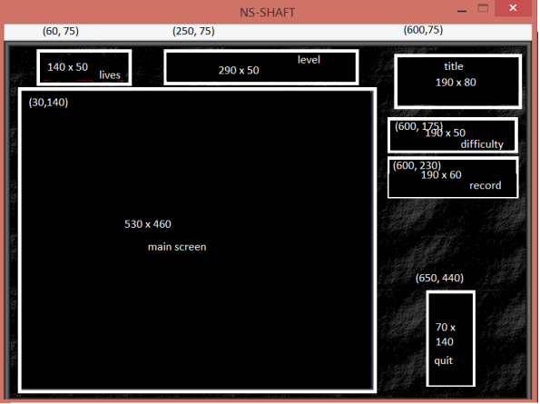

Game in play

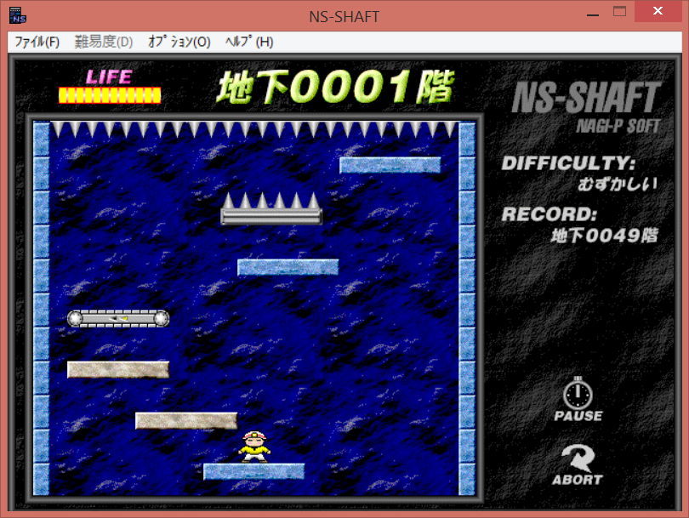

Top spike

Normal platform

Spike platform

Rolling platform

Flip platform

Player

Player is injured

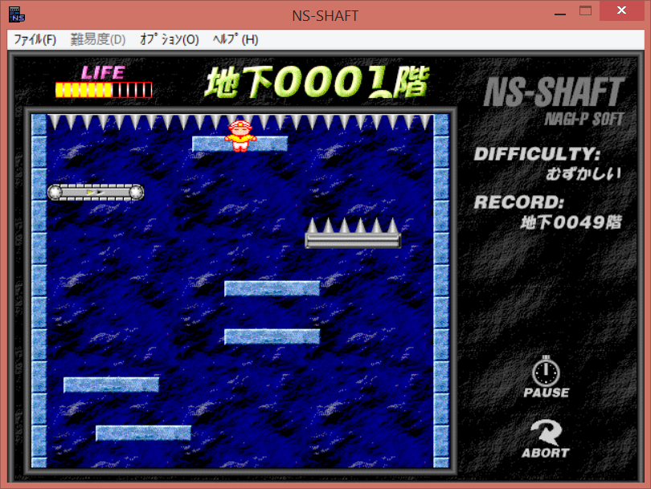

NS-Shaft. Version 1.3. 1996. Video game.